**Smart connected Signs for Improved Road Safety**

**In present Systems the road signs and the speed limits are Static. But the road signs can be changed in some cases. We can consider some cases when there are some road diversions due to heavy traffic or due to accidents then we can change the road signs accordingly if they are digitalized.This project proposes a system which has digital sign boards on which the signs can be changed dynamically.If there is rainfall then the roads will be slippery and the speed limit would be decreased.There is a web app through which you can enter the data of the road diversions, accident prone areas and the information sign boards can be entered through web app. This data is retrieved and displayed on the sign boards accordingly.**

**Software used**

* **Arduino IDE**
* **Embedded C**

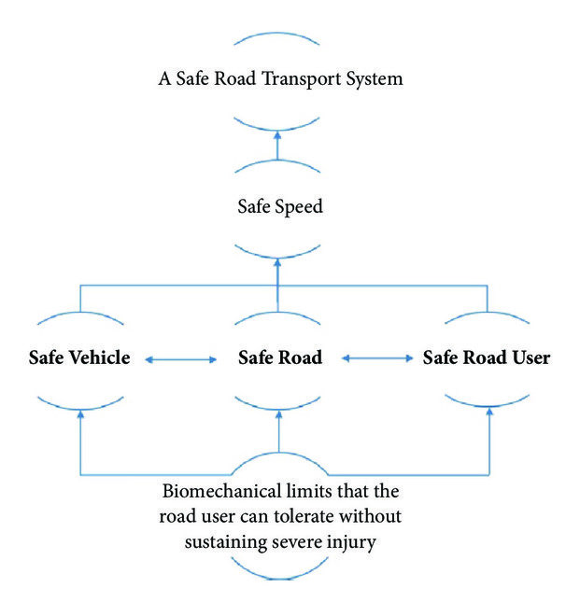

Our interest in this work is to complement the approach with a short-to-medium term dynamic assessment of road safety. Toward this end, we introduce a novel, cost-effective Internet of Things (IoT) architecture that facilitates the realization of a robust and dynamic computational core in assessing the safety of a road network and its elements. In doing so, we introduce a new, meaningful, and scalable metric for assessing road safety. We also showcase the use of machine learning in the design of the metric computation core through a novel application of Hidden Markov Models (HMMs). Finally, the impact of the proposed architecture is demonstrated through an application to safety-based route planning.

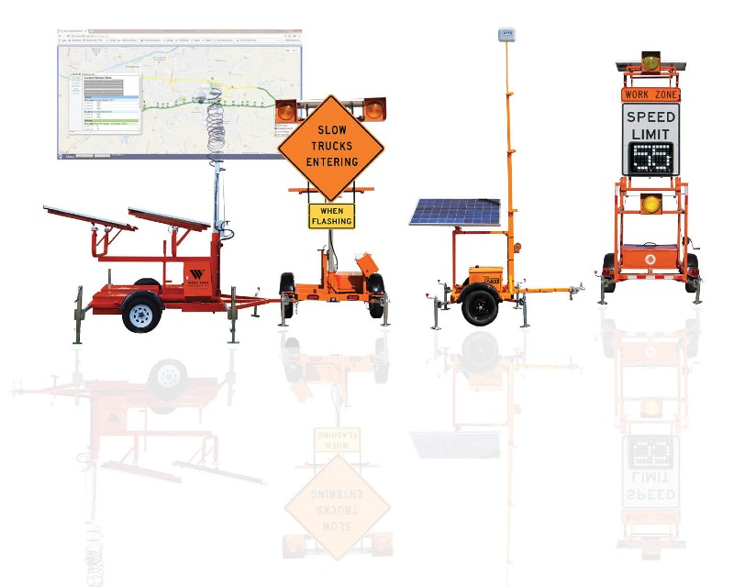

**Are They Already in Use?**

Smart roadway signage is not simply an objective for the future. Two UK companies have collaborated to produce these signs for use [**on England’s roads**](https://www.smartcitiesworld.net/news/news/uk-installs-next-generation-digital-signage-on-its-roads-4499).

The signs are technologically advanced, with graphics and text that drivers can see clearly. The messages are easy to comprehend quickly, keeping drivers informed of route conditions as they change.

In addition to enhancing the roadway experience for users, this new signage costs less to maintain than traditional indicators. The new signs require fewer materials and less cabling, resulting in less time, upkeep, and expense.

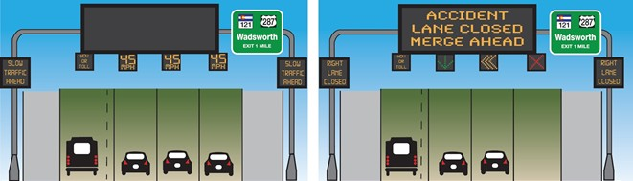

## Improving Our Lives with Smart Road Signs

Clearly, intelligent roadway placards can be a vital part of our driving experience. They enable a better way for drivers to access the information they need in real time on the roads. These signs can increase awareness of upcoming issues, which people might otherwise discover too late.

They may also augment the functionality of driverless vehicles.  
The value of implementing this technology should not be underestimated. Smart roadway indicators have the potential to increase cost-efficiency, which eases the burden on governments and taxpayers. They facilitate a smoother driving process for both human drivers and autonomous vehicles.

The placards can be more user-friendly than the analog route signs we currently employ. Above all, they may ultimately lead to a safer network of roads for everyone.

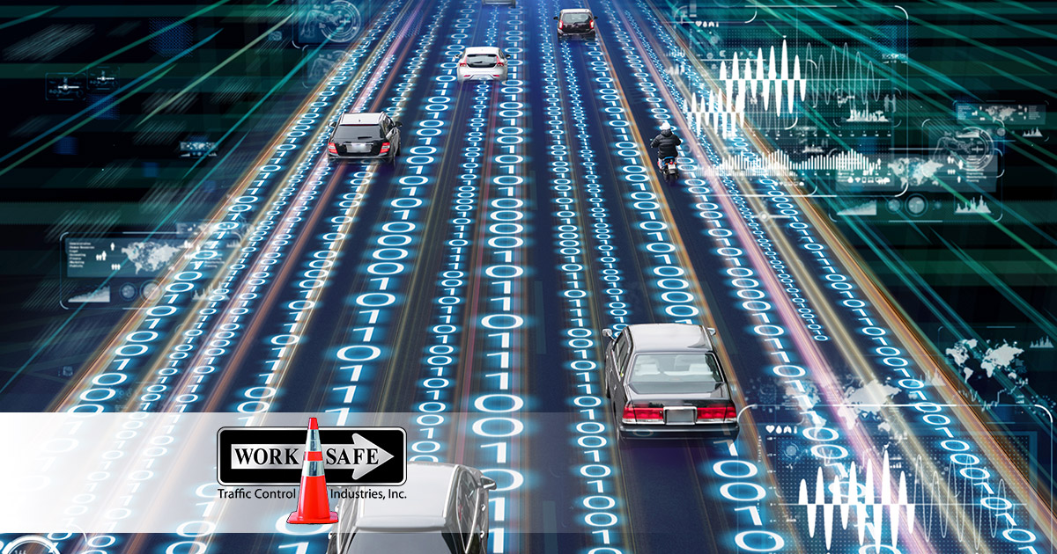

DONE BY:

**B5-5M1E**

ADHITHYAN.M.S(TL)

DHARUN ANTONY(M1)

DHINESH RAM(M2)

BHARATHWAJ(M3)